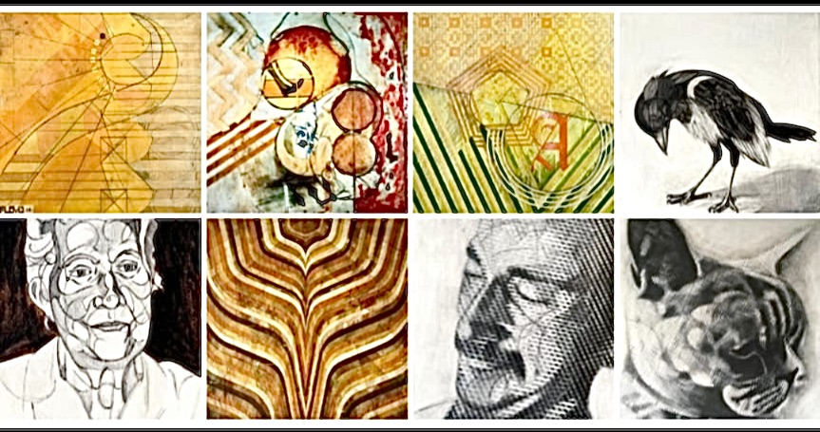
Examples of Ben Floyd’s artwork, showing his unique style

